Shadi Jiha #40131284 25/01/2020

Winter 2020 Assignment 1

**COMP 228 Assignment 1 Solution**

**Question 1:**

|  |  |  |  |
| --- | --- | --- | --- |
|  | A | B | Time |
| Serial | % | % | 100% |
| Parallel |  |  |  |
| Max () |  |  | 250 times |

Solve for x first, and then find p for 75% of 250 and then 90% of 250.

Find x:

1. How much processors do we need to speed up by 187.5 (75% of 250)?

processors

1. How much processors do we need to speed up by 225 (90% of 250)?

processors

EW

|  |  |  |  |
| --- | --- | --- | --- |
|  | A | B | Time |
| Serial |  |  |  |
| Parallel |  |  |  |
| Max () |  |  | S seconds |

Find the value of s:

Find the value of x:

Find the value of y:

Solution:

**Question 2:**

We have:

and

Find b:

Power usage:

SOLUTION:

1. We need beta and alpha
2. Total performance: and power dissipation

**Question 3:**

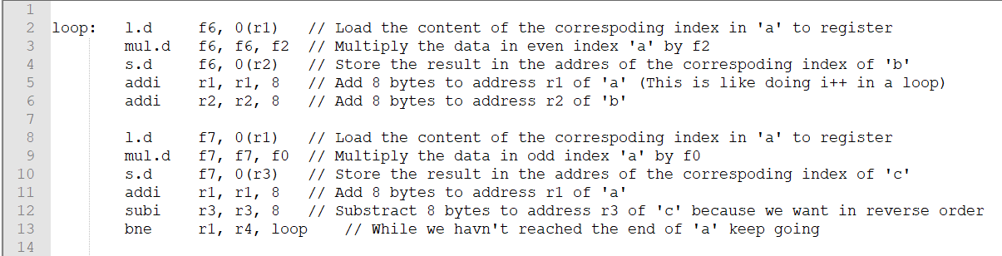Consider f6 and f7 as registers. The Code will be:

**Question 4:**

The datastore (also called pipeline) is the unit that executes the instructions. All of fetch unit and branch unit require access to it because the need to know which instruction to execute next in a program.

**Question 5:**

1. 8 GBs =
2. 35 TBs =
3. 1.05 EBs =
4. 0.5 EBs =

**Question 6:**

So AI = 0.632 flops/byte

1. At peak:
2. Double the BW:

AI = 0.316 flops/byte

1. Power efficiency:
2. Depending on his need, if he wants to process more data and power usage isn’t an issue, the costumer can ignore the power efficiency.